CS 461

Lab Assignment 3

Name: Gandhi Dhruv Vipulkumar

Institute ID: 202151053

Date: 23-9-2024

**Q. Implement multiple client and multiple server architecture using Java.**

**MultiServer.java**

import java.io.*;  
import java.net.ServerSocket;  
import java.net.Socket;  
import java.util.concurrent.ExecutorService;  
import java.util.concurrent.Executors;  
  
public class MultiServer {  
  
    // Each server listens on a different port, same Wi-Fi IP address  
    private static final String SERVER_IP = "192.168.1.14";  
    private static final int PORT = 5557; // Change for each server instance like 5555, 5556, 5557, etc.  
    private static final int THREAD_POOL_SIZE = 10; // Fixed thread pool size  
  
    public static void main(String[] args) {  
        ExecutorService clientHandlerPool = Executors.newFixedThreadPool(THREAD_POOL_SIZE);  
  
        try (ServerSocket serverSocket = new ServerSocket(PORT)) {  
            System.out.println("Server is listening on " + SERVER_IP + ":" + PORT);  
  
            while (true) {  
                Socket clientSocket = serverSocket.accept();  
                System.out.println("New client connected: " + clientSocket.getInetAddress());  
                clientHandlerPool.execute(new ClientHandler(clientSocket)); // Handle each client in a separate thread  
            }  
  
        } catch (IOException e) {  
            e.printStackTrace();  
        }  
    }  
}  
  
class ClientHandler implements Runnable {  
  
    private final Socket clientSocket;  
  
    public ClientHandler(Socket socket) {  
        this.clientSocket = socket;  
    }  
  
    @Override  
    public void run() {  
        try (BufferedReader in = new BufferedReader(new InputStreamReader(clientSocket.getInputStream()));  
                PrintWriter out = new PrintWriter(clientSocket.getOutputStream(), true)) {  
  
            String message;  
            while ((message = in.readLine()) != null) {  
                System.out.println("Received: " + message);  
                out.println("Echo: " + message); // Echo back the message  
            }  
  
        } catch (IOException e) {  
            System.err.println("Error handling client: " + e.getMessage());  
        } finally {  
            try {  
                clientSocket.close();  
            } catch (IOException e) {  
                e.printStackTrace();  
            }  
        }  
    }  
}

**Client.java**

import java.io.*;  
import java.net.Socket;  
   
public class Client {  
   
    public static void main(String[] args) {  
        // Replace with the Wi-Fi IP address of the server and respective port  
        String SERVER_IP = "192.168.1.14"; // Same Wi-Fi IP address for all servers  
        int SERVER_PORT = 5557; // Change this to connect to different servers (5555, 5556, etc.)  
   
        try (Socket socket = new Socket(SERVER_IP, SERVER_PORT);  
                BufferedReader in = new BufferedReader(new InputStreamReader(socket.getInputStream()));  
                PrintWriter out = new PrintWriter(socket.getOutputStream(), true);  
                BufferedReader userInput = new BufferedReader(new InputStreamReader(System.in))) {  
   
            // Start a thread to read server responses  
            Thread readThread = new Thread(() -> {  
                String response;  
                try {  
                    while ((response = in.readLine()) != null) {  
                        System.out.println("Server: " + response);  
                    }  
                } catch (IOException e) {  
                    System.err.println("Error reading from server: " + e.getMessage());  
                }  
            });  
            readThread.start();  
   
            // Sending user input to the server  
            String message;  
            while ((message = userInput.readLine()) != null) {  
                out.println(message); // Send message to server  
            }  
        } catch (IOException e) {  
            e.printStackTrace();  
        }  
    }  
}

**Code Explanation:**

* The server is running on a machine with IP address assigned by Wifi router and multiple instance of server are created on different PORT, and each instances are running at a same time.
* The Clients are connecting with different IP addresses to different ports hosted by server.
* Multiple clients can send message to different server instances.

**Testing Phase:**

**IP address of clients:**

Client-1: 192.168.1.2

Client-2: 192.186.1.10

Client-3: 192.168.1.14

**IP address of servers:**

* 192.168.1.14:5555
* 192.168.1.14:5556
* 192.168.1.14:5557

**1) Client-1 sending greetings on server 192.168.1.14:5556**

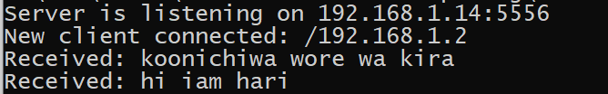

**2) Client-2 sending message on server 192.168.1.14:5555**

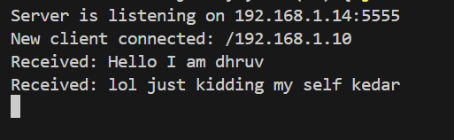

**3) Client-3 sending message on server 192.168.1.14:5557**

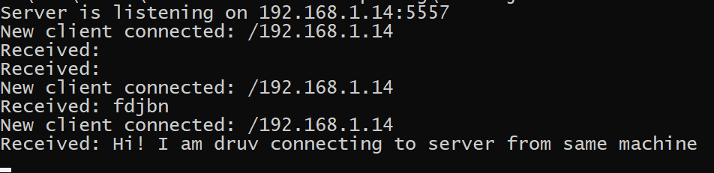

**Note:** All the communication is happening at same time.

**Conclusion:** Multiple clients can send messages to different servers simultaneously.